Assessing pesticide fate at catchment scale using the CSIA concept

Objectives, sampling, extraction protocols and experimental setup (07.04.2016)

Contents

1. Gaps of knowledge 3

2. Research questions 3

3. Experimental design 4

3.1. Study site 4

3.2. Data collection: 4

4. Water Sampling & Analysis 6

4.1. Automatic Sampler Pacing (Asservissement) 6

4.2. Doppler flowmeter – 2150 Isco (Débitmètre): 6

4.3. Catchment Outlet Probe (Sonde) 7

4.4. Water sampling: weekly routine 7

4.5. Water sample preparation and analysis (laboratory) 7

4.6. Water filtration: as soon as possible after sampling 9

4.7. Water extraction SPE: as soon as possible after filtration 10

5. Soil Sampling & Analysis 13

5.1. Weekly Soil Sampling 13

5.2. Detailed Soil Sampling (Initial, +1, +50 & +100 days) 16

5.3. Labeling – Detailed Soil Samples 19

5.4. Soil sample preparation and analysis (laboratory) 20

5.5. Soil preparation: Sieve as soon as possible after sampling 21

5.6. Suspended particulate matter - SPM (filters) 22

5.7. SPM Pesticide extraction 22

5.8. Water content determination 22

5.9. pH determination 23

5.10. Organic matter determination 26

5.11. Notes (to keep in mind for e.g. CSIA applications) 28

6. Hydrodynamic parameters 29

6.1. Soil surface characterization approach 29

6.2. Background theory 29

6.3. Infiltration equation 30

6.4. Materials & infiltrometer description 30

6.5. Methodology for K and S Determination 32

6.6. Apparent Density (AD) 33

6.7. Choosing an appropriate methodology 34

7. Landscape observation and measurement 35

8. References 36

Appendix 1 – Doppler flowmeter (Débitmètre) 37

Appendix 2 – Automatic Sampler (Pre-leveur) 38

Appendix 3 – Multiparameter Probe (Sonde Multiparametre) 39

Appendix 4 – Tipping Bucket / Rain gauge (Pluviometre) 41

# Gaps of knowledge

* Approaches allowing quantitative evaluation of the contribution of specific processes and pathways for *pesticide removal in agricultural catchments* are urgently needed.
* *Concepts and approaches involving stable isotope chemistry* offer a unique opportunity to obtain information on sources, transport routes, and degradation pathways of numerous classes of organic contaminants.
* Stable isotope analysis offers an exceptional opportunity to obtain decisive information on physical and (bio-) chemical processes making use of kinetic and equilibrium isotope effects. Thus *identification of sources, degradation pathways, transport and sinks of pesticides in the agricultural soils and runoff water and suspended solids* is our scientific target.
* Thus far, isotope approaches and field applications are available for common point source groundwater contaminants, such as fuel components and chlorinated solvents but are *still mostly lacking for emerging and persistent contaminants, e.g. pesticides, which are regionally and/or globally dispersed*.
* *Multi-element isotope fingerprinting (C, H and N) of pesticides enable the joint analysis of the transformation pathways* using isotope fractionation processes affecting the reactive position of a molecule as well as the isotope fingerprint of an organic target compound to reveal its origin and sources.
* For the special case of chiral micropollutants, strongest insights in the degradation mechanisms is provided by combining CSIA and enantioselective analysis in the so-called *enantio-specific stable isotope analysis (ESIA)*. *ESIA has never been applied in soil and water for chiral pesticides at the catchment scale*.
* Methods for isolation and concentration of chloroacetanilide pesticides, used here as model agricultural pesticides, from soil and water for quantification (GCMS) and stable isotope analysis (IRMS) have been developed in our research group (lhyges). However, *those methods have not been applied to evaluate the temporal and spatial variation of in-situ degradation in soil and water of agricultural catchments* *and prove the applicability of CSIA approach in agricultural catchment*.
* *Conceptual hydrological model to assist the integrative interpretation of discharge, concentrations and CSIA data of pesticide are currently missing*.

# Research questions

This study aims:

1. *To apply and validate the approach of CSIA (C and N isotopes) and ESIA of pesticides* at the agricultural catchment scale to identify the **spatial and temporal evolution** of the pesticide sources, **degradation in soil** and transport in runoff water and suspended solids from the catchment.
2. *To develop a conceptual hydrological model* that describes pesticide transport, degradation and associated isotope/enantiomer fractionation in agricultural catchment to identify the dominant processes affecting S-metolachlor.

The following questions are addressed:

* How the degradation of S-metolachlor in the soil evolve over space and time in relation to **variability of** hydrological (i.e. moisture content, temperature) and chemical (i.e. soil organic carbon content, pH, Eh) conditions?
* How the transport (export from the agricultural catchment) of S-metolachlor its ESA and OXA TPs in surface runoff and in suspended solids evolve over time in relation to **variability of** physical (i.e. Ksat, soil bulk density, soil water retention, surface roughness, root growth and vegetation cover, soil cohesion), hydrological (i.e. duration, intensity) and chemical (i.e. soil organic carbon content, pH, Eh) conditions?
* What are the potential and limits of coupling CSIA, ESIA and enantiomer analyses to evaluate the dynamics of S-metolachlor degradation and transport at the agricultural catchment scale?
* Can CSIA approaches allow for i) identifying in situ degradation in soil and runoff, ii) distinguishing degradation pathways (biotic versus abiotic), and iii) estimate the extent of degradation based on current Rayleigh distillation models?
* How can conceptual hydrological modelling help in the description and interpretation of pesticide transport, degradation and associated isotope fractionation in agricultural catchment to identify the dominant processes affecting pesticides?
* What is the added value of CSIA data in a combined monitoring and modeling approach for the assessment of transport and degradation of pesticides at catchment scale?

# Experimental design

## Study site

The study is conducted in a 47-ha headwater catchment, located 30 km north of Strasbourg (Alteckendorf, Alsace, France). The mean annual temperature between 2005 and 2011 was 11.7 °C, and mean annual precipitation and potential evapotranspiration were 704 mm (± 151 mm) and 820 mm (± 28 mm), respectively (data from Meteo France station in Waltenheim sur Zorn at 7 km distance from the catchment). Arable land (with corn and sugar beet as main crops) comprises 88 % of the catchment area, with the remainder being roads, and patches of grass. The mean catchment slope is 6.7% (± 4.8%), ranging in elevation between 190 m and 230 m. The main soil type is calcareous brown earth, with approximately 80% calcic soils in upland catchment areas and 20% colluvial deposits along the thalweg. Soil characteristics (CaCO3: 5.8 ± 8.5%; pH: 7.3 ± 0.3; %OM: 5.86 ± 0.62) and grain size distributions (sand: 11.4 ± 8.0%; silt: 64.0 ± 5.9%; clay: 25.1 ± 3.1%; n=48) in the study area were assumed homogeneous in the following analyses.

The catchment is drained by an artificial drainage network of unknown size; at least one drainpipe was active during the study and continuously discharged into the ditch upstream of the catchment outlet (Fig. 1). A detailed description of the study catchment can be found in Lefrancq (2014).

|  |  |
| --- | --- |
|  | **Figure 1.** Scheme of the Alteckendorf catchment (Alsace, France) in 2012 (to be updated for 2016). OC and D1 indicate the outlets of the catchment and the drainage system, respectively. P1 shows the location of a pipe that conducts runoff water below a path. There is no experimental plot in 2016. |
|  |  |

## Data collection:

*Campaign duration:*

*1st Stage: April 04 2016 to July 15 2016 (15 campaigns)*

*2nd Stage: September 01 to October 28 2016 (9 campaigns)*.

*Pre-campaign information*

* S-metolachlor application rates and locations are obtained from survey to the farmers (Sylvain)
* Map with culture plots to be provided (Sylvain)

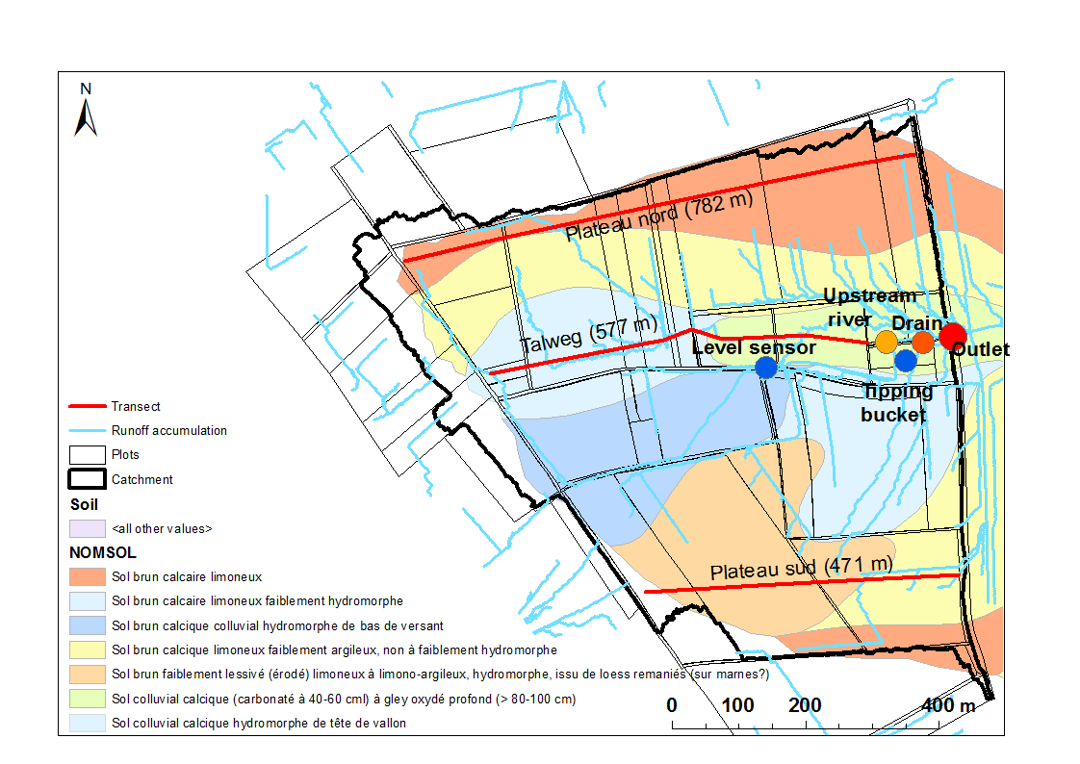

**Map 1.** Soil sample collection transect at the Alteckendorf catchment, France.

# Water Sampling & Analysis

## Automatic Sampler Pacing (Asservissement)

The Refrigerated automatic sampler (Isco Avalanche) collects flow proportional samples in carrousel of 12 glass bottles (Vol. per bottle = 350 mL). Based on the maximum expected discharged volume observed in 2012 three time periods with different pacing have been calculated[1] and outlined below.

To calculate pacing and obtain a composite sample per week the following equation is used:

$$Composite sample vol=\frac{Exp. Vol [L]}{Week No.[-]}÷\frac{Vol [L]}{pulse [-]}×Aliquote Vol. [mL]÷No. of pulses[-]$$

|  |  |  |  |  |  |  |  |
| --- | --- | --- | --- | --- | --- | --- | --- |
|  | **Exp. Catchment Vol. / Week** | **Vol. [L] / pulse** | **Aliquot size [mL]** | **No. of pulses** | **Composite  Sample Vol.** | | **Bottles Used** |
| **Season** | (see 'Tot. Vol. per Week' tab for idea on max vol.) | (Doppler's Fixed Pulse Vol) | (3 samples / bottle ) | (see 'Pulses Per Day' tab for idea on a min. pulse size) | [mL] | **[L]** | **No. [-] (330mL each)** |
| **Spring** | 313 000,00 | 500,00 | 115 | 40 | 1 799,75 | **1,80** | **5,5** |
| **Summer Early** | 1 560 000,00 | 500,00 | 115 | 120 | 2 990,00 | **2,99** | **9,1** |
| **Summer Late** | 541 000,00 | 500,00 | 115 | 80 | 1 555,38 | **1,56** | **4,7** |

***See also, Operating Procedures****: Appendix 2 – Automatic refrigerated sampler (Preleveur)*

## Doppler flowmeter – 2150 Isco (Débitmètre):

The Doppler flow meter calculates discharge at the catchment outlet by measuring water depth and the given diameter of the discharge pipe.

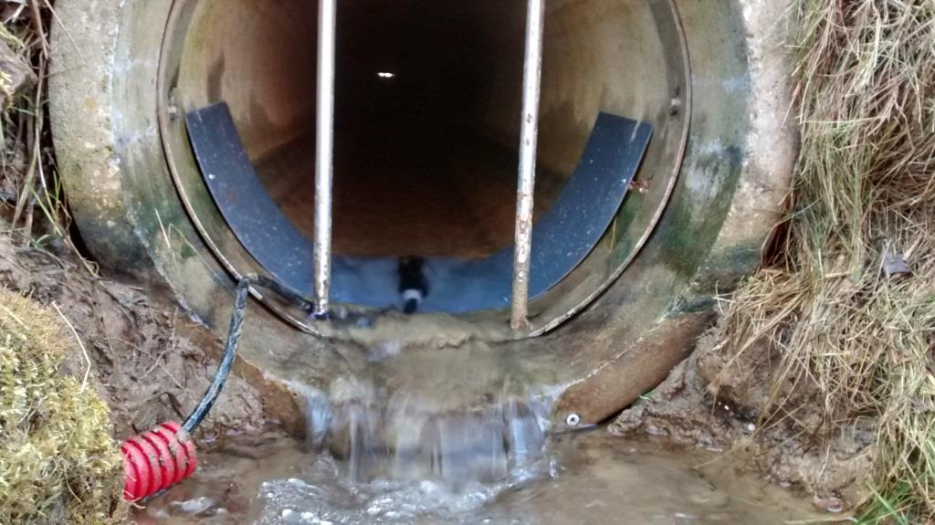 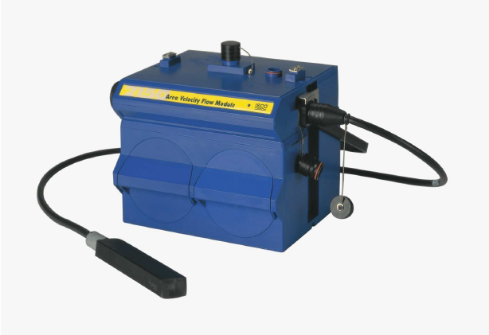

Every 500L one pulse is sent to the automatic sampler. The pulse size is set as default and cannot be changed for the flow meter. Pacing options need to be therefore adjusted on the automatic sampler.

***See also******Operating Procedures****: Annex 1 – Doppler flow meter (Devitmetre).*

## Catchment Outlet Probe (Sonde)

The following parameters are measured continuously at the catchment outlet by use of a *Hanna Instruments* Probe:

1. *Temperature*
2. *Conductivity*
3. *pH*
4. *Dissolved oxygen*

Weekly, this probe is to be calibrated according to the Probe’s calibration protocol. See ***Operating Procedure: Appendix 3*** *– Probe multi-parameter (Sonde)* (Ask Benoit)

## Water sampling: weekly routine

Each week, samples are collected in the glass bottles at the Alteckendorf Catchment Outlet (ACO) **– 1 to 12 bottles of 350 mL each** andstored in a cool box. The same number of sample bottles is replaced with new clean bottles and new caps. **Water samples are stored in the dark at 4 °C after each runoff event and placed on ice during transportation to the laboratory for chemical analysis (within 24 hs following the sample collection).**

## Water sample preparation and analysis (laboratory)

The main target analyses in water samples are:

1. Metolachlor, ESA and OXA concentrations (liquid and sorbed phase)
2. Metolachlor steroisomer fractions (x4, unless 2 enantiomers are possible)
3. Isotope signatures (C, N)

Concentration range of target pesticides for method setup is: **0.1 - 300µg/L**

However, in addition to the main target analyses in water (1) suspended solids, (2) organic matter content (in suspended solids), (3) key hydro-chemical parameters and (4) total elements are to be measured weekly, except for #4, which is to be obtained only for detailed soil sampling campaign dates (i.e. x4 times per season).

The following diagram summarizes the water analysis requirements. The key steps are described in detailed also below.



## Water filtration: as soon as possible after sampling

Before any filtration takes place **conditioning** of the material needs to be conducted. The procedure is described below:

* Installer l’unité de filtration sur une paillasse ou dans un endroit propre et sec.
* Mettre un filtre dans l’une des 2 unités en verre. Utilisez une pince en métal pour cela. Faire une filtration avec le col de filtration rempli d’eau ultra-pure ou Elix. Démonter le récipient collecteur de l’unité de filtration afin de bien pouvoir faire passer l’eau sur toutes les parois de l’unité. Jeter l’eau. Récupérez le filtre et le mettre sur l’autre unité. La première servira au rinçage des filtres et la seconde à la filtration des échantillons.
* Remonter le tout. Mélangez l’échantillon à filtrer et le filtrer avec le col de filtration rempli à moitié avec l’échantillon. Procédez de la même façon qu’avec l’eau ultra-pure (démontage de la partie inférieure afin de bien conditionner toute l’unité. Conditionner également le flacon en PP recevant le filtrat. Jetez l’échantillon ainsi que le filtre et remonter).
* Garder au minimum 15 ml brut à mettre dans des flacons PP (situés dans les armoires de la mezzanine du laboratoire). Bien étiqueter ces flacons et les mettre au frais.

**Analysis I. Suspended Solids & Organic Matter – MES & MO (40 mL)**

*Materials:*

* Filtres 0,7 µm de porosité et 47 mm de diamètre en verre.
* Un flacon d’un demi-litre en verre brun (dans mezzanine du laboratoire au premier étage).
* Eau ultra-pure ou Elix.
* Coupelle + étuve + four
* 1 tube Falcon propre.
* Eprouvette en verre
* Pince en fer

*Procedure:*

* Filtrer 40 ml (0,7 µm) avec une unité en verre (en prenant soin d’avoir rincé le filtre avec 200 ou 250 ml d’eau ultra-pure ou désionisée avant la filtration – i.e. conditioning).
* Peser une coupelle propre, mettre ce filtre dans la coupelle à l’étuve. Une fois le filtre sec, peser l’ensemble.
* Mettre 15 ml dans un flacon en PP, bien étiqueter (Sarah’s ettiquettes) et conserver au frais. Conserver ce filtre pour les MES et le MO.
* Filtrer ensuite sur ce filtre en verre les 40 mL d’échantillon mis de côté (noter le volume exacte).
* Sécher 2 h à 105 °C. Peser pour obtenir la masse de MES puis mettre dans le four 16 h à 375 °C. Peser à nouveau l’ensemble pour avoir la masse de MO. Bien étiqueter les flacons de filtrat (Sarah’s ettiquettes) et les tubes Falcon recevant les filtres (Sarah’s ettiquettes).

**Analysis II. Hydrochemistry (15 mL)**

*Materials:*

* Filtres 0,45 µm de porosité et 47 mm de diamètre en acétate de cellulose.
* 2 unités de filtration en verre avec pompe à vide.
* Eau ultra-pure ou Elix.
* Flacons PP de 100 ml (situés dans les armoires de la mezzanine du laboratoire).
* Tubes ICP de 15 ml.
* Acide nitrique concentré (10 ou 15N)

*Procedure:*

* Filtrer 40 ml (0,45 µm) avec une unité en verre (en prenant soin d’avoir rincé le filtre avec 200 ou 250 ml d’eau ultra-pure ou désionisée avant la filtration – i.e. conditioning). Mettre 15 ml dans un flacon en PP, bien étiqueter (Sarah’s ettiquettes).
* Mettre 10 ml dans un tube ICP et acidifier avec une ou deux gouttes d’HNO3 puis stocker au frais bien étiquetés (Sarah’s ettiquettes).
* Ces échantillons sont à donner tous les mois à Sophie G. ou Colin F. pour les flacons en PP (analyses chromatographiques) et à René B. pour les tubes ICP (analyses ICP).
* Conserver 15 ml dans un flacon puis stocker au frais bien étiquetés (Sarah’s ettiquettes -Analyses-complémentaires) en attendant de rapidement mesuré les paramètres suivants pH, Eh, EC et turbidité. Puis passer à l’ultracentrifugation. ( ??)
* Si il y a une semaine sans eau, essayer de filtrer plus les autres semaines de façon à avoir toujours un litre à la fin du mois.

**Analysis III. Pesticides (rest of sample volume)**

*Materials:*

* Filtres 0,45 µm de porosité et 47 mm de diamètre en acétate de cellulose.
* 2 unités de filtration en verre avec pompe à vide.
* Eau ultra-pure ou Elix.
* 1 tube Falcon propre (to keep filters aside for extraction following the “soil” protocol
* Un flacon d’un demi-litre en verre brun (dans mezzanine du laboratoire au premier étage).

*Procedure :*

* Filtrer l’ensemble de l’échantillon (0,45 µm) en faisant passer un volume connu sur les filtres en acétate de cellulose (le mesurer avec l’éprouvette en verre). Les garder dans un tube Falcon propre et étiqueté (avec le volume inscrit par filtre) au congélateur. Ces filtres serviront à analyser les pesticides adsorbés.

## Water extraction SPE: as soon as possible after filtration

After filtration solid-phase extraction (SPE) is conducted by concentrating under nitrogen flux to 1 droplet, and re-suspended in 800 µL ACN. S-metolachlor, MESA and MOXA are quantified with a GC-MS/MS and LC-MS/MS system according to Charline’s/Benoît’s protocols:

Follow the SPE extraction procedure developed for aromatic acetanilides (Method #X) :

1. Book time on the SPE calendar
2. Make sure that the SPE apparatus is ready to operate

Check : N2 flux (8 bars at the bottle outlet), solvents and wastes levels and connections to the SPE apparatus

1. Load the following program :
2. Wash syringe with 5,0 mL ethanol (EtOH)
3. Rinse cartridge with 5,0 mL acetonitrile (ACN) into solvent waste
4. Rinse cartridge with 5,0 mL distilled water (H2O) into aqueous waste
5. Condition cartridge with 5,0 mL distilled water (H2O) into aqueous waste
6. Load *XX* mL of sample onto the cartridge *(enter the volume of your sample and save the method)*
7. Dry cartridge with gas for 10,0 minutes
8. Soak and Collect 3,0 mL fraction using ethyl acetate (EtAc)
9. Collect 2,0 mL fraction into sample tube using EtAc
10. Soak and Collect 3,0 mL fraction using ACN
11. Collect 2,0 mL fraction into sample tube using ACN
12. Insert Dionex® C18 Cartridges at the 6 available locations of the SPE apparatus
13. Transfer the filtrated water in a flask
14. Insert the tubes from the SPE apparatus in the sample flasks

Make sure that the tube touches the bottom of the flask

Maintain the position of the tube in the flask with parafilm

1. Place a 10 mL amber glass flask at each SPE outlet
2. Start the loaded SPE program
3. Preconcentrate the samples by solvent evaporation under N2 flux until the “last drop”, using the appropriate program
4. Rinse 2 times with 400 µL ACN and transfer into a 2 mL GC vial
5. Store the extract in a freezer until analysis

Label properly the sample (extract type, date of sampling and extraction and your name)

**Solvent Set**

Use the “isotopes_acetanilides” solvent set :

1. Ethanol (EtOH)
2. Distilled water (H2O)
3. Ethyl Acetate (EtAc)
4. Not used; Default solvent: Dichloromethane (DCM)
5. Acetonitrile (ACN)

**Parameters**

* Flow rates :

|  |  |  |  |
| --- | --- | --- | --- |
|  | **1 L sample** | **2 L sample** | **≤ 500 mL sample** |
| **Cond Flow** | 40,0 mL/min | 40,0 mL/min | 40,0 mL/min |
| **Load Flow** | 10,0 mL/min | 30,0 mL/min | 10,0 mL/min |
| **Rinse Flow** | 40,0 mL/min | 40,0 mL/min | 40,0 mL/min |
| **Elute Flow** | 5,0 mL/min | 5,0 mL/min | 5,0 mL/min |
| **Cond Air Push** | 15,0 mL/min | 15,0 mL/min | 15,0 mL/min |
| **Rinse Air Push** | 20,0 mL/min | 20,0 mL/min | 20,0 mL/min |
| **Elute Air Push** | 5,0 mL/min | 5,0 mL/min | 5,0 mL/min |

* SPE parameters

|  |  |
| --- | --- |
| Push Delay | 5 sec |
| Air Factor | 1,0 |
| Autowash Volume | 1,00 mL |

* Instrument Parameters

|  |  |
| --- | --- |
| Max Elution Volume | 12,0 mL |

**Notes:**

* S-metolachlor enantiomer analysis is carried out with a Trace GC 2000 series GC-MS apparatus (Thermo Fisher Scientific, Waltham, MA, USA) equipped with 30 m × 0.25 mm ID, 0.25 µm film 20% tert-butyldimethylsilyl-β-cyclodextrin dissolved in 15% phenyl-, 85% methylpolysiloxane chiral column (BGB Analytik, Boeckten, Switzerland) as previously described (Elsayed et al., 2015).
* C and N isotope ratios are measured in triplicates with a GC-C-IRMS continuous-flow system (Delta V plus); ESIA of S-metolachlor is carried with a 30 m × 0.25 mm ID, 0.25 µm film 20% tert-butyldimethylsilyl-β-cyclodextrin dissolved in 15% phenyl-, 85% methylpolysiloxane chiral column (BGB Analytik, Boeckten, Switzerland).

# Soil Sampling & Analysis

## Weekly Soil Sampling



Weekly composite topsoil samples (0 - 3 cm) (ONLY on the maize and sugar beet plots) are collected along each transect (i.e. 3 composite samples, one per transect). The tables 5.1-3 below (and respective figure) indicate the location of sampling points. Each accompanying figure provides the coordinates of the plot boundaries and the sampling centers at the transect crossing for each plot. At each sampling center five samples are taken with a stainless steel spoon, two meters apart, as shown on transect crossing figure. A portable thermometer should be used to record the temperature of the soil at the sample point (one measurement per sampling center).

*Table 5.1 Composite Sample: Alteckendorf Weekly(AW)–North (N)-week number*

|  |  |  |  |  |  |  |  |  |  |
| --- | --- | --- | --- | --- | --- | --- | --- | --- | --- |
| Code Transect | Plot's Width [m] | | | | | | | | **Total** |
| Farmer | Kopp | Kopp | Kopp | Dutt | Kopp | Dutt | Friess | Speich |  |
| AW-N- | 98 | 41 | 33 | 42 | 47 | 130 | 173,5 | 60,1 | **624,6** |
| Distance % of Transect | 15,7% | 6,6% | 5,3% | 6,7% | 7,5% | 20,8% | 27,8% | 10% | **100%** |
| Sampling Centers | **5** | **2** | **2** | **2** | **2** | **6** | **8** | **3** | **30** |
| Distance [m] btw points | 17 | 18 | | 14 | 15 | 20 | 21 | 15 | 1350 |
| Distance to neighbours' boundary | (13m) | (9m) | | (13m) | (16m) | (15m) | (12m) | (15m) | Composite Mass [g] |

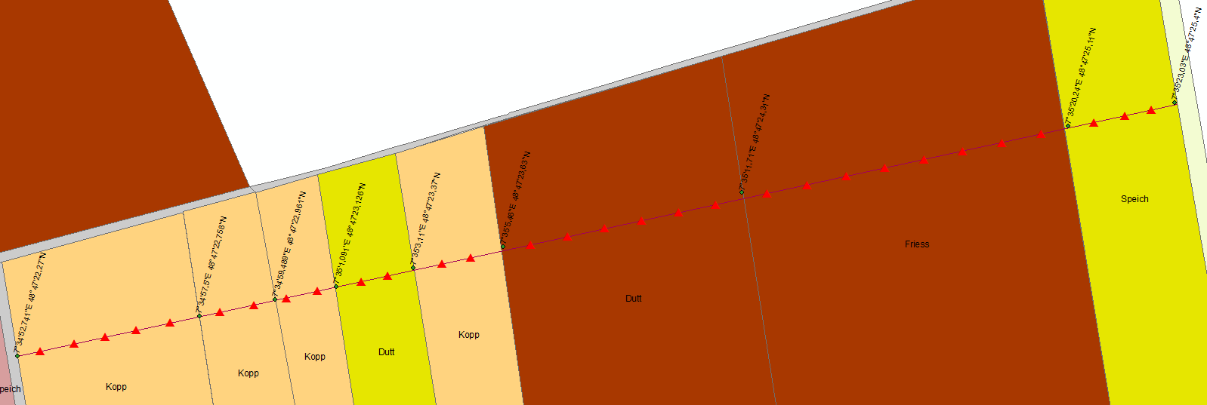

*Table 5.2 Composite Sample: Alteckendorf Weekly(AW)–Talweg (T)-week number*

|  |  |  |  |  |  |  |  |  |
| --- | --- | --- | --- | --- | --- | --- | --- | --- |
| Code Transect | Plot's Width [m] | | | | | | | **Total** |
| Farmer | Kopp | Kopp | Kopp | Dutt | Kopp | Schmitt | Friess |  |
| AW-T- | 96,5 | 45 | 28,6 | 43,8 | 35,8 | 117 | 135,8 | **502,5** |
| Distance % of Transect | 19,2% | 9,0% | 5,7% | 8,7% | 7,1% | 23,3% | 27,0% | **100%** |
| Sampling Centers | **5** | **2** | **2** | **2** | **2** | **6** | **6** | **25** |
| Distance [m] btw points | 16 | 20 | | 15 | 12 | 17 | 20 | 1125 |
| Distance to neighbours' boundary | (15m) | (7m) | | (14m) | (-) | (15m) | (15m) | Composite Mass [g] |

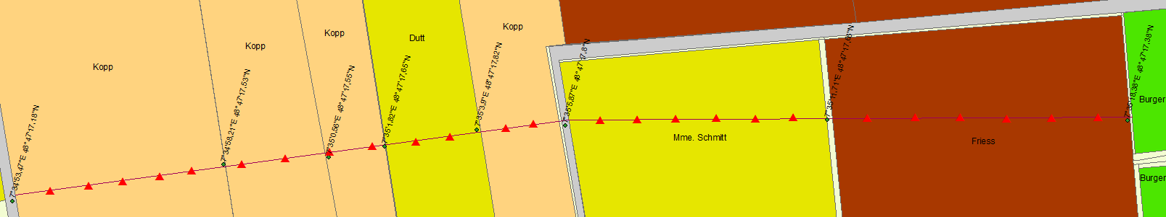

*Table 5.3 Composite Sample: Alteckendorf Weekly(AW)–South (S)- week number*

|  |  |  |  |  |
| --- | --- | --- | --- | --- |
| Code Transect | Plot's Width [m] | | | **Total** |
| AW-S- | 86,2 | 179,8 | 218 | **484** |
| Distance % of Transect | 18% | 37% | 45% | **100%** |
| Sampling Centers | **5** | **10** | **12** | **26** |
| Distance [m] btw points | 15,0 | 18,0 | 17,0 | 1170 |
| Distance to neighbours' boundary | (13m) | (7m) | (21m) | Composite Mass [g] |

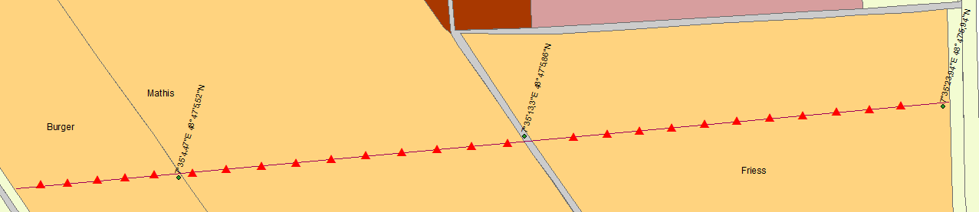

## Detailed Soil Sampling (Initial, +1, +50 & +100 days)

Detailed soil samples are collected separately for each maize or beet plot falling within the given transect line. Sample points at given intervals within each transect are shown in Tables 5.4-6 along with their respective location-specific figures. Sampling is to be carried out before (initial state), immediately after S-metolachlor application (+1 day) and at +50 and +100 days after application. If application takes place at different times, during weekly sampling an additional detailed sampling is to be conducted in addition only for those parcels where S-metolachlor has been applied. At each sampling point, samples will be collected for 2 different depths (top soil at 3cm and 20cm) in different bags. 20 cm samples will be collected with a hand auger. A portable thermometer should be used to record the temperature of the soil at each depth at the sample point (one measurement per depth per sampling center).

*Table 5.4 Detailed Samples: Alteckendorf Weekly(AW)–North (N)-Day number-PlotID-Depth*

|  |  |  |  |  |  |  |  |  |
| --- | --- | --- | --- | --- | --- | --- | --- | --- |
| Code Transect | Plot's Width [m] | | | | | | | **Total** |
| A-N-(I,II,III,IV)-Plot#-D3/D20 | 98 | 74 | 42 | 47 | 130 | 173,5 | 60,1 | **624,6** |
| Distance % of Transect | 15,7% | 11,8% | 6,7% | 7,5% | 20,8% | 27,8% | 9,6% | **100%** |
| Sampling Centers | **5** | **5** | **4** | **4** | **6** | **6** | **4** | **34** |
| Distance [m] btw points | 18,4 | 13,0 | 9,0 | 10,3 | 20,7 | 27,9 | 13,5 |  |
| Distance to neighbours' boundary | (11m) | (10.5m) | (7m) | (7m) | (16m) | (17m) | (9m) |  |

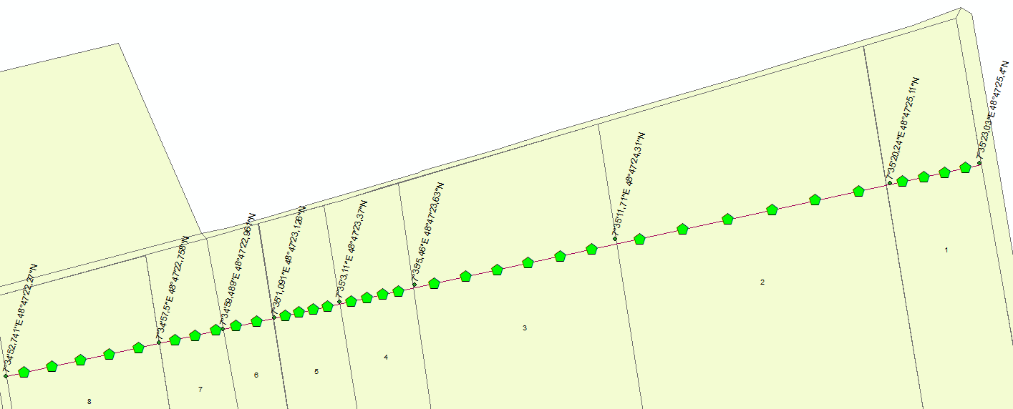

*Table 5.5 Detailed Samples: Alteckendorf)–Talweg (T)-Day number-PlotID-Depth*

|  |  |  |  |  |  |  |  |
| --- | --- | --- | --- | --- | --- | --- | --- |
| Code Transect | Plot's Width [m] | | | | | | **Total** |
| A-T-(I,II,III,IV)-(Plot#)-D3/D20 | 96,50 | 73,6 | 43,80 | 35,80 | 117,00 | 135,80 | **502,5** |
| Distance % of Transect | 19,2% | 14,6% | 8,7% | 7,1% | 23,3% | 27,0% | **100%** |
| Sampling Centers | **5** | **5** | **4** | **4** | **6** | **6** | **30** |
| Distance [m] btw points | 18,1 | 13,0 | 9,5 | 7,5 | 18,5 | 21,6 |  |
| Distance to neighbours' boundary | (11m) | (10.5m) | (7.5m) | Measure directly | (12m) | (14m) |  |

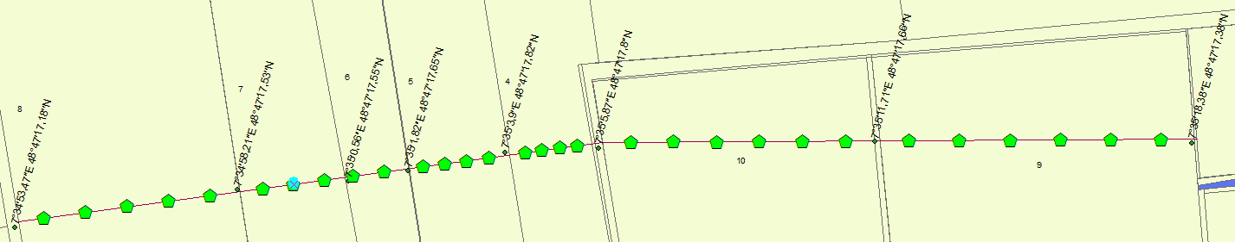

*Table 5.6 Detailed Samples: Alteckendorf)–South (S)-Day number-PlotID-Depth*

|  |  |  |  |  |
| --- | --- | --- | --- | --- |
| **Code Transect** | **Plot's Width [m]** | | | **Total** |
| A-S-(I,II,III,IV)-(Plot#)-D3/D20 | 86,2 | 179,8 | 218 | 484 |
| Distance % of Transect | 17,8% | 37,1% | 45,0% | 100% |
| **Sampling Centers** | **5** | **7** | **8** | **20** |
| Distance [m] btw points | 16,0 | 24,8 | 26,5 |  |
| Distance to neighbours' boundary | (9m) | (14m) | (14m) |  |

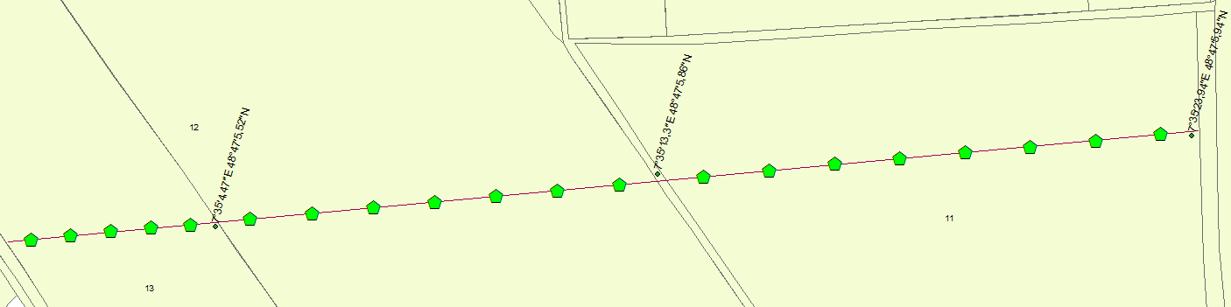

## Labeling – Detailed Soil Samples

## Soil sample preparation and analysis (laboratory)

The main target analyses in soil samples are:

1. Metolachlor, ESA and OXA concentrations
2. Metolachlor steroisomer fractions (all 4 fractions if possible)
3. Isotope signatures (C, N)
4. Moisture content

Concentration range of target pesticides for method setup is: **0.1 - 300µg/L**

However, in addition to the main target analyses, (1) organic matter and (2) pH are to be measured at the beginning, middle and end of the season (March 29th, May 31st and July 19th 2016) for each plot’s composite sample collected on that date.

The following diagram summarizes the required soil analyses. The key steps are described in detailed below.



## Soil preparation: Sieve as soon as possible after sampling

1. Do **NOT** dry the soil: drying the sample might affect the pesticide content and/or microbial activity3,4
2. Weigh each sample (in its sampling bag)
3. Homogenize the sample with a Riffle splitter: pass the sample twice in the splitter. If the initial sample weigh is above 500g, keep only half of the sample to sieve, otherwise sieve the whole sample.  
   **Note:** this step is **necessary** for the sample from the catchment area but could be skipped for the plots if the samples are < 300g
4. Weigh the empty sampling bag
5. For samples > 500g, put the soil to discard in the original weighted sampling bag and weigh
6. Quarter the sample following the quartering procedure shown in the figure below (NF X 31-101):



1. Sieve the remaining soil with a 2mm mesh: the sample through the 2-mm sieve, grind the fraction above 2mm (in the pot), pass this fraction through the 2-mm sieve
2. Weigh the fraction of particles > 2mm in the empty sampling bag
3. Store about **2*30 g of sieved soil** in 40mL amber glass bottles in a fridge for water content determination (see next step)
4. Store about **2*20 g of sieved soil** in 40mL amber glass bottles in a fridge for pH determination
5. Store at least **2*30g of sieved sample** in 50mL amber glass bottles in a freezer until extraction (fill the bottle to the ¾ and weigh)

**Note:** Label properly each bottle with the type of samples, dates of sampling **and** sieving, exact mass of soil in the bottle and your initials.

## Suspended particulate matter - SPM (filters)

The “suspended particulate matter (SPM)” corresponds to the fraction collected on filters during water filtration.

Store the filters in 15 mL falcon tubes closed with screw caps and parafilm in a freezer until extraction.

## SPM Pesticide extraction

* S-metolachlor, MESA and MOXA are extracted, concentrated and purified from soil samples based on Charline s’/Benoît’s protocol.
* Follow the “Soil extraction” procedure, while adapting the volumes to your mass of suspended matter.

## Water content determination

The following is a description of the protocol from Margesin and Schinner (2005)3 for field-moist samples.

1. Homogenize 1*30 g of sieved soil from each transect separately or from each of the plots separately.
2. Place the soil on a clean surface that **does not absorb** moisture (e.g. a glass plate) and mix well. Remove particles with a diameter > 2mm.
3. Dry container with lid at 105±5°C and then cool it, with the lid closed in desiccator for at least 45 minutes. Determine the mass (m0) of the closed container with an accuracy of ±1 mg.
4. Transfer 30-40 g of soil to this container using a spoon.
5. Determine the mass (m1) of the closed container and soil with an accuracy of ±10mg.
6. Dry the container and soil in an oven at 105°C until constant mass is achieved. Dry the lid at the same time.
7. Cool the container with the lid closed in a desiccator for at least 45 min.
8. Remove the container from the desiccator and immediately determine the mass (m2) of the closed container containing the oven-dried soil with an accuracy of ±10mg.

Calculation:

Calculate the dry mass content (wdm) or water content (wH2O) on a dry mass basis expressed as percentage by the mass to an accuracy of 0.1% (m/m) using the following equations:

$$w_{dm}=\frac{m_{2}-m_{0}}{m_{1}-m_{0}}×100$$

$$w_{H_{2}O}=\frac{m_{1}-m_{2}}{m_{2}-m_{0}}×100$$

where:

*m0 =* mass of the empty container with lid (g)

*m1 =* mass of the container with air-dried soil or field-moist soil (g)

*m2 =* mass of the container plus oven-dried soil (g)

## pH determination

**

**

**

**

**

**

**

## Organic matter determination

**

**

**

**

**

**

**

**

**

## Notes (to keep in mind for e.g. CSIA applications)

* Ivdra et al. (2014)6 used a mixture of Pent/DCM (3/1, v/v) for soil extraction
* Up to 3 pre-concentrated fractions can be combined without any significant carbon isotope (δ13C) effect6
* Ivdra et al. (2014)6 used sulfuric acid for the extract clean-up, and reported negligible losses and insignificant δ13C fractionation6 => Tests to be performed with the procedure from Anastassiades and Lehotay (2003)5

# Hydrodynamic parameters

To reproduce single rainfall-runoff events agricultural hydrological models require calibration of initial physical parameters that are dynamic and subject to environmental processes (i.e. hydrological forcing, vegetation growth, soil characteristics). Lefrancq et al (2012) conducted a sensitivity analysis (Figure V-5) to evaluate the primary input parameters requiring greatest calibration and measurement efforts. Their results show that Ksat, Ѳ and n parameters do play a significant role constraining the model predictions.

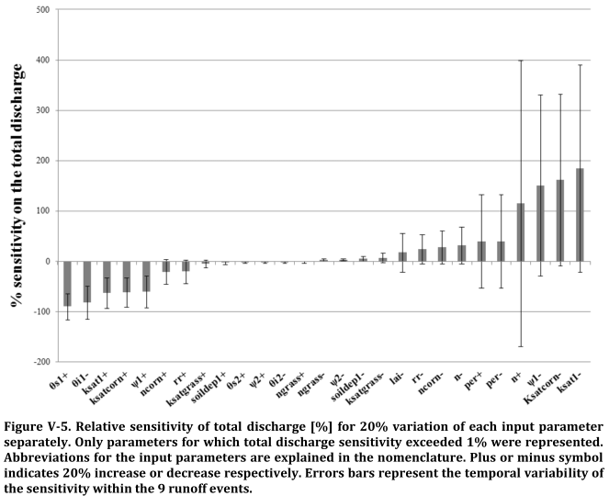

*Sensitivity of initial calibration parameters to total discharge (Lefrancq et al., 2012)*

## Soil surface characterization approach

To obtain representative information of spatio-temporal variability of the two most sensitive parameters shown above (i.e. Ѳi and ksat) a mini-disk infiltrometer method will be employed (see figure below). The infiltrometer allows obtaining hydraulic conductivity parameters near saturation as well as information on macroporosity distribution by measuring infiltration at a constant charge. This method has been successfully used to obtain mean values and standard deviations of these parameters at a catchment scale (e.g. Kirkby, 2014) and is well described in Winterer (2011).

## Background theory

Vandervaere et al. (2000a) discuss several methods to describe vertical infiltration by way of a tension infiltrometer. Their results indicate axysimetric infiltration can be described by a two term equation corresponding to functions of the hydraulic conductivity K and the sorptivity S. Fitting experimental results, the linear regression with a differentiated linearization (DL) is the most robust method and is capable of representing the influence of the sand layer used by disk infiltrometers. In Vandervaere et al. (2000b) the accuracy of four methodologies used with disk infiltrometers is discussed and indicate their dependence on the combination of S and K values obtained during experimentation. Three conditions are highlighted that are important in choosing the correct methodology to determine field measurements:

1. Flow is dominated by the lateral capillarity term;
2. Flow is dominated by the gravity term;
3. Lateral capillarity and gravity terms have equivalent weights.

## Infiltration equation

Axisymmetric infiltration is described by a one dimensional vertical infiltration equation:

$$I= C_{1}\sqrt{t}+C_{2}t$$

where I is the cumulative infiltration depth (mm), C1 = *S* is capillary sorptivity (mm/s0.5), *t* is elapsed time (s) and C2 is a gravity term given by:

$$C_{2}=\frac{2-β}{3}K+\frac{γS^{2}}{R(θ_{f}-θ_{i})}$$

where β is a constant in the interval (0,1) and typically equal to 0.6, K is the hydraulic conductivity (mm/s), γ = 0.75, S is capillary sorptivity (mm/s0.5), R the disk radius (mm), Ѳf and Ѳi the final and initial volumetric moisture content, respectively.

The differentiated linearization (DL) method used to fit the linear regression graphically is obtained by differentiating above and yielding:

$$\frac{dI}{d\sqrt{t}}= C_{1}+2C_{2}\sqrt{t } and \frac{dI}{d\sqrt{t}}≅ \frac{I_{i+1}-I_{i}}{\sqrt{t_{i+1}}-\sqrt{t_{i}}}$$

with i the time step at which the measure is taken, elapsed I is the infiltrated length (mm), t elapsed time and the corresponding √t is calculated as the geometric mean:

$$\sqrt{t}= {\left[\sqrt{t_{i}t_{i+1}} \right]}^{1/2}$$

## Materials & infiltrometer description

* Disk[2] (steel) (**D**) and membrane (**A**)
* Graduated water reservoir (**RA**)
* Stopper *(pince de Mohr)*
* Suction control tube (**B**) linked to a mariotte tube (**VM**) via bubble chamber

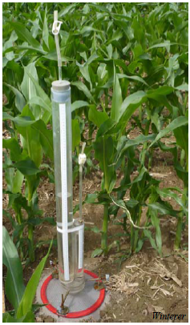 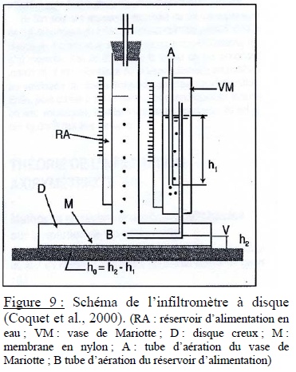

Mini-disk infiltrometer (Winterer, 2011; Coquet et al., 2000)

*« L’infiltromètre est constitué d'un disque creux (D) muni d'une membrane (M) à sa base en contact avec le sol. Le disque est alimenté en eau par un réservoir (RA) gradué, amovible et fermé à sa partie supérieure par une pince de Mohr (Figure above). L’entrée de l'air dans le réservoir d'alimentation se fait par un tube (B) relié à un vase de Mariotte (VM) permettant de régler le potentiel de l'eau au niveau de la surface du sol. Pour que l'eau quitte l'infiltromètre et s'infiltre dans le sol, elle doit être remplacée dans le réservoir d'alimentation par un volume identique d'air. Cet air transite à travers le vase de Mariotte de A jusqu'à B. L’air entre dans le vase de Mariotte par le tube A à la pression atmosphérique. Les bulles d'air ainsi formées à la base du tube A remontent dans le vase de Mariotte et rejoignent le volume d'air contenu dans celui-ci. Lors de l'infiltration de l'eau, l'air quitte le vase de Mariotte par le tube B à la pression pair VM pour rejoindre le réservoir d'alimentation. L’eau située juste à la sortie du tube B a donc une pression égale à celle de l'air qui sort du tube, si l'on néglige l'effet de la tension superficielle de l'eau dans l'air à la sortie de ce tube (remarque valable aussi pour le tube A).*

*Si l'on exprime les pressions en unité de hauteur de colonne d'eau, un potentiel de l'eau h0 à la sortie de l'infiltromètre: h0=h2-h1. Ce dispositif permet donc de contrôler et maintenir la pression de l'eau à l'interface infiltromètre/sol. Dans la pratique, la hauteur h2 est déterminée en remontant le tube A jusqu'à ce que l'eau coule à travers la membrane. On a alors h0 = 0 et h1 = h2. Le tube A est alors rabaissé de la distance correspondant au potentiel h0 désiré. La membrane du disque doit avoir un potentiel d'entrée d'air bien inférieur à -25cm tout en ayant une résistance hydraulique négligeable devant celle du sol » (Coquet et al., 2000).*

*Trois diamètres de disque sont disponibles pour faire les mesures : 250mm, 80mm et 48,5mm. Nous avons choisi d’utiliser le disque de diamètre 250mm dans le but d’avoir une surface la plus grande possible. Trois potentiels sont appliqués (-7, -3 et -1,5cm) dans les parcelles en labour pour obtenir les courbes de rétention. Pour les parcelles en TCSL et en SD, les mesures d’infiltration sont faites au potentiel -3cm (Annexe 1 : feuille de terrain TRIMS). »*

## Methodology for K and S Determination

Use of the disk infiltrometer assumes that measurements will be taken during transient flow conditions and that flow conditions are adequately represented by the two parameter equation and its differentiated linearization as described by Vandervaere et al. (2000). The following flowchart describes the first part of the test (i.e. Determining dominant flow conditions), which is required before completing a full data set with accurate K and S estimations.



Part I

1. Take a surface soil sample near the area where infiltration test will take place. This sample will be used to determine initial moisture content (Ѳi). Water content will be determined as described in Chapter 5.8 (above).

Part II

1. Choose a flat surface to ensure hydraulic contact across the entire disk space
2. A template of the size of the disk is used to remove debris, clumps, stones, cut vegetation;
3. Slightly humidify the soil surface with a water spray bottle;
4. Place <2 mm of sand across the space evenly;
5. Place infiltrometer horizontally with a level ruler.

**Note: this preparation is important to not damage the canvas disk and to obtain a correct measurement.**

Part III

1. Fill the infiltrometer with water
2. Remove air bubbles inside the disk (which reduce infiltration surface)
3. Régler le tube A dans le vase de Mariotte pour faire le zéro (potentiel égal 0, l’eau est à la pression atmosphérique) puis à régler le potentiel choisi en abaissant A dans le VM.
4. The experiment starts as soon as the infiltrometer is placed (straight) on the ground, at which point time of infiltration should start to be recorded (i.e. t=1).
5. During the first 10 minutes of the experiment, cumulative time is recorded for each 0.5cm of infiltration (i.e. to characterize sorptivity)
6. After record cumulative time (i.e. elapsed) at every 1cm of infiltration.
7. Quasi-steady state is achieved after 45min (stop experiment before the entire reservoir is empty).
8. After infiltration experiment is finished, remove sand to take a soil sample to determine final moisture content (Ѳf) (repeat for each infiltration replica).
9. Tension -7cm: Only one repetition is necessary
10. Tension -3cm and -1.5cm: Repeat twice (or three times if the measurement times are different).
11. Replicas are separated by a distance of at least 60cm.

## Apparent Density (AD)

Samples are taken with an open-ended metallic cylinder with a volume Vc of 100cm3, until a depth of 5cm. After closing, weigh to obtain the wet mass (WM). Once in the laboratory, dry at 105°C for 48h, after which the dry mass (DM) is weighted. Empty the cylinder and weigh it to obtain the tare mass. A minimum of 4 samples are taken for each average value.

To calculate the following calculation is made:

$$AD=\frac{DM-T}{V_{c}}$$

where AD is the apparent density (g/cm3), DM is the dried mass (g), T mass tare (g), Vc the volume of the cylinder (cm3).

## Choosing an appropriate methodology

After the relationship to Sopt has been determined a decision is to be made regarding the methodology to be used in determining K and S values. While a Single Test (ST) method (i.e. used to determine relationship to Sopt) may be accurate for full sampling, this is only true for cases b and c below. Nevertheless, even under such conditions using the ST method may not yield reliable S values, indicating advantages for a Multi-Radii approach.



# Landscape observation and measurement

Observations methods still to document….

* Leaf Area Index (LAI) & surface roughness (parametrization of manning’s n)

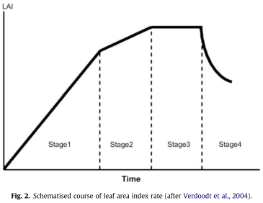

* Confirmation of Local Drain Direction (LDD) Network (and its evolution)

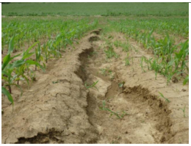

# References

1. Andreu, V. & Picó, Y. Determination of pesticides and their degradation products in soil: critical review and comparison of methods. *TrAC Trends Anal. Chem.* **23,** 772–789 (2004).

2. Pinto, C. G. *et al.* Simplified QuEChERS approach for the extraction of chlorinated compounds from soil samples. *Talanta* **81,** 385–391 (2010).

3. Margesin, R. & Schinner, F. *Manual for soil analysis monitoring and assessing soil bioremediation*. (Springer, 2005). at <http://public.eblib.com/choice/publicfullrecord.aspx?p=304261>

4. Redondo, M. J., Ruiz, M. J., Boluda, R. & Font, G. Determination of pesticides in soil samples by solid phase extraction disks. *Chromatographia* **36,** 187–190 (1993).

5. Anastassiades, M., Lehotay, S. J., Stajnbaher, D. & Schenck, F. J. Fast and easy multiresidue method employing acetonitrile extraction/partitioning and ‘dispersive solid-phase extraction’ for the determination of pesticide residues in produce. *J. AOAC Int.* **86,** 412–431 (2003).

6. Ivdra, N., Herrero-Martín, S. & Fischer, A. Validation of user- and environmentally friendly extraction and clean-up methods for compound-specific stable carbon isotope analysis of organochlorine pesticides and their metabolites in soils. *J. Chromatogr. A* **1355,** 36–45 (2014).

7. Lesueur, C., Gartner, M., Mentler, A. & Fuerhacker, M. Comparison of four extraction methods for the analysis of 24 pesticides in soil samples with gas chromatography–mass spectrometry and liquid chromatography–ion trap–mass spectrometry. *Talanta* **75,** 284–293 (2008).

# Appendix 1 – Doppler flowmeter (Débitmètre)

|  |  |
| --- | --- |
| ***Débitmètre*** *Doppler flow meter (Débitmètre)*  *Operating Procedure* |  |
| ***Data Recovery:***   * *Connect the PC to the flowmeter. The connection is made in the top slot of the device. The corresponding cable has a label (DOPPLER).* * *Open the software « Flowlink ».* * *In the left column, open successively the study site to the monitored parameters (ALTEC). A new window will appear.* * *At the bottom left of this window, there will be a button « CONNECTER (F7) ». Click to connect.* * *After reaching the connection, at the top right corner of the window it will be written « CONNECTE » in green. At the bottom left of the window, the button «TRANS. VAL. (F8) » will be able. Click to transfer the data to the PC. A transfer window will appear. Closed the transfer window, the data is already saved in the database computer.* * *To see the data, click on « GRAPHIQUE DEFAUL(F9) ». A graph will appear. It’s necessary to change the properties of the graph to show the period of time, measures and units of measurement as you want. For that, click left on the graphic and go to « PROPRIETES ». In the window that appears, it is possible to make choices as desired.* * *In « ECHELLE DE TEMPS », check « Absolu » and enter the date and time of data recovery beginning.* * *Enter the number of days you want in the data range.* * *Confirm with « OK ».* * *Keep the data by clicking on the icon of a house with a sun* * *Click on the icon « graph/table » to go in tabular form.* * *Go to « Fichier » then « Exporter » to has as excel format.* | |
| ***Change number of decimal places on a parameter :***   * *Right click on the graph.* * *Go to the tab « propriétés », then into « séries ».Highlight the parameter to change.* * *Uncheck « résolution implicite ».* * *Change the values.* * *Confirm with « OK ».* | |
| **En cas de problèmes** :  Avec Flowlink :   * Si les données récemment récupérées ne s’affichent pas sur le graphe :   Il suffit de rajouter une série de données (hauteur) en allant chercher les données de Rouffach et Factory.  Avec le matériel ISCO :   * Si la hauteur relevée est aberrante, il est possible de modifier arbitrairement cette valeur pour recaler l’appareil correctement :   Dans le menu principal de l’écran de l’appareil ISCO, choisir « voir données ».  Faire défiler le menu jusqu’à « caler/ajuster paramètre », où il est alors possible de modifier la valeur de la hauteur d’eau. | |

# Appendix 2 – Automatic Sampler (Pre-leveur)

|  |  |
| --- | --- |
| ***Pre-leveur*** *Automatic refrigerated sampler (Pre-leveur)*  *Operating Procedure* |  |
| ***Contents:***   * *24 glass bottles of 1L* * *A vinyl cover for each bottle (i.e. for trip back to the laboratory)* * *Rotating water dispenser* * *Carousel with metal plate to hold bottles in place* * *Hose and suction extending between sampler intake and discharge outlet* | |
| ***Materials / equipment needed:***   * *24 glass bottles of 1L + caps* * *A vinyl cover for each bottle (i.e. for trip back to the laboratory)* * *Computer* *CEVH (login : cevh ; password : engees)* * *Cooler with frozen ice packs* | |
| ***Sample recovery:***   * *Interrupt the program by clicking "stop program" in the main menu screen of the device* * *Open the refrigerated compartment and remove the glass bottles (1 L glass bottles), including also empty bottles.* * *Immediately close and place the glass bottles in the transport cooler with ice-packs* * *Replace with the new 24 empty glass bottles* * *Place new bag of 24 plastic caps for next field visit (inside the fridge or on top of sampler)* * *Close the fridge door & lock* | |
| ***Battery change:***   * *Click on "stop programme".* * *Press-shut-down button* * ***Safety measures for changing batteries?*** * *Exchange old with new car batteries (2x)* | |
| ***Re-launch the sampling program :***   * *Click on "stop programme".* * *Follow the procedure by validating each time the pre-set option (normally it is already set so there is nothing to change)* * *Continue to monitor the procedure and at the end of it, choose "lancer le programme"* | |
| ***Labelling :***   * *Label the bottle with date of sampling according to the code created. Essential to avoid confusion and to distinguish between Alteckendorf and Rouffach samples after they are stored in the laboratory.* | |
| ***Transportation***   * *Samples are to be placed in cooler with ice pack.* * *Closed and stored in the dark* * *Once in the laboratory samples are to be filtered within 24 hrs (and if possible also analyzed within this time frame* | |

# Appendix 3 – Multiparameter Probe (Sonde Multiparametre)

|  |  |
| --- | --- |
| ***Annex 3******-***  ***Sonde Multiparametre*** *Probe multi-parameter (Pre-leveur)*  *Operating Procedure* | *Afficher l'image d'origine* |
| ***Contents:***   * *Multisensor probe (pH/ORP/EC/O2/°C)* * *Computer with software HI92000* | |
| ***Materials / equipment needed:***   * *Computer with software HI92000* * *HI9828-25 quick calibration standard solution, 500 mL* * *Calibration beaker* * *USB interface cable (HI7698281)* * *Distilled water* * *O2 membrane (to be replaced once a month ?)* | |
| ***Data gathering:***   * *With the meter OFF, disconnect the probe.*   *(Appuyer sur « Arrêt » au niveau de la sonde.)*   * *Connect the USB adapter to the meter and to the USB port on PC and turn the meter ON.*   *(Brancher le câble noir (avec d’un côté une prise ronde qui correspond au branchement sur le boitier de la sonde et de l’autre, une prise USB))*   * *Run the HI92000 software, select the number of the used COM port within the “Settings” window and then press “Connect”. In “ lot name”, choose “Alteck”*   *(Ouvrir le logiciel HI929828. Cliquer sur « Connect » puis choisir le site « Alteck » dans « Lot name »)*   * *Press « Get lot ». The data should appear.*   *(Cliquer sur « Get lot ». Le tableau de résultats devrait apparaitre)*   * *Save it in the file “Alteck/données sonde”*   *(L’enregistrer dans le dossier Alteck/données sonde.)* | |
| ***Data logging :***   * *Connect the probe to the meter.*   *(Pour pouvoir programmer, il faut brancher la sonde au boitier.)*   * *Press « Log » to store the readings or « Menu » to enter in the main menu*   *(2 icônes apparaissent en bas : « Enreg. » et « Menu ».)*  *To change the log interval, press “Menu” and select “Measurement setup”. Press “OK”*  *(Dans Menu/Config. du système, on peut choisir l’intervalle d’enregistrements.)*   * *Press “Log” and then “OK” to store the enabled readings in the last lot (here Alteck.)*   *(Dans Enreg., si on choisit « OK », on enregistre simplement les données ponctuelles dans le dernier lot utilisé (ici Alteck))*   * *Press “Options” and “Continuous” to select the continuous logging mode*   *(Choisir donc « Options » puis en continu (sinon nous n’aurons qu’une donnée ponctuelle))*   * *Select the lot ”Alteck” (or create a new one)*   *(Choisir maintenant le lot « Alteck » (ou en créer un nouveau si un nouveau site d’étude est en cours d’installation))*   * *Press OK to confirm, add a remark if necessary and press “skip” to skip the “tag option”.*   *(Cliquer « OK » puis mettre une remarque si besoin (en général pas nécessaire) et ignorer le Tag (cela permet d’associer un numéro d’identification à la valeur mise en mémoire). L’enregistrement est lancé.)* | |
| ***Cleaning steps:***   * *Clean the probe with distilled water* | |
| ***Calibration steps:***  *To be done once a week*   * *Clean the probe with distilled water* * *Fill the calibration beaker with the HI9828-25 calibration solution* * *Screw the calibration beaker on the probe body and shake gently for a few seconds* * *Wait a few minutes to stabilize* * *In the main menu, select “Calibration” and then press “OK”* * *Select the calibration type (here : quick calibration) and then press “OK”*   *A 3-item (pH, EC and DO) screen appears and “pH” starts blinking. When the measure is stable, “Ready” is shown on the lower part of the window.*   * *Press “Confirm” to store the value.*   *The messages “Storing data on probe, please wait…” and “Updating GLP data, please wait…“ appear*   * *After the pH calibration is completed, the “Conductivity” option will blink. When the measure is stable, “Ready” appears. Press “Confirm” to store the value.*   *The messages “Storing data on probe, please wait…” and “Updating GLP data, please wait…“ appear*   * *The message “Empty the beaker. Shake the probe and put it in the beaker again” appears. Unscrew the calibration beaker and remove the solution.* * *To dry the probe, shake it. Pay attention that no drops are present on the DO sensor.*   *(Do not use paper to dry the probe to avoid sensor damages)*   * *Screw back the calibration beaker on the probe body.* * *Wait for reading to stabilize and then press “OK” to close the displayed message.* * *When the measure is stable, “Ready” appears. Press “Confirm” to store the value.*   *The messages “Storing data on probe, please wait…” and “Updating GLP data, please wait…” appear.*   * *The 3-calibration-item screen appears again and the check box corresponding to the calibrated parameters will be marked. Press “OK” to return to the calibration menu.* | |
| ***Membrane replacement :***  *To be done once a month* | |

# Appendix 4 – Tipping Bucket / Rain gauge (Pluviometre)

|  |  |  |  |  |
| --- | --- | --- | --- | --- |
| ***Pluviometre*** *(à auget basculeur)*  *Operating Procedure* | | ***Cone*** | | ***G:\DCIM\100OLYMP\P3090281.JPG Data logger*** |
| ***Equipment:***   * *Cône de 1000 cm2 (Résolution de 0,2 mm - Contact du basculement au mercure permet cette précision ainsi qu’une grande robustesse - 18 000 tilts (basculements)* * *Datalogger* * ***Computer software:*** | | | | |
| ***Data gathering:***   * *Remove data logger from its support casing*   *(Commencer par enlever le datalogger de son support)*   * *Connet USB cable between computer and data logger*   *(Brancher le câble USB entre le datalogger et le PC.)*   * *Start software : «* ***Teram Term Pluvio DANAE*** *»* * *Choose «Serial» instead of «TCP/IP»*   *(Cocher « Serial » au lieu de « TCP/IP »)*   * *Click « OK »* * *Press « e » then « entrée » to obtain the number of tilts*   *(Cela nous donne le nombre de basculement(s) ainsi que les caractéristiques du matériel)*   * *Press « t » then « entrée » to obtain access to all tilts (date and time).*   *(Pour avoir accès à tous les basculements (date et heure)).*   * *Save data by copying it to a block-note file and store it in « données pluvio »*   *( « Enregistrer ces données en passant par le bloc-note et mettre dans le dossier « données pluvio »).* | | | | |
| ***Change date & time:***   * *Press “h” to adjust date-time* | | | | |
| ***Clean memory***   * *Press “r” to put memory back to zero*   *(Cleans memory to collect data only for the week)* | | | | |
| ***Level check***   * *Verify the rain-gauge level with the integrated level-bubble (as clay soils may shift the level of the concrete block)* * *If incorrect, modify with the help of two* ***molettes bleues.*** | *Photo*  ***Level Bubble*** | | *Photo*  ***Mollettes*** | |
| ***Battery check***   * *Press “e” to check battery life****.*** | | | | |

**Soil extraction**

**Extract clean-up**

***Adapted from Anastassiades and Lehotay (2003)6***

**Soil extraction**

***Adapted from Ivdra et al. (2014)3***

5 g of soil In a 50 mL falcon tube centrifuge tube with screw cap

+ 1 to 10 mL (2:1 soil sample/solvent ratio) -> 2.5mL EtOAc

Vortex 15 s

Ultrasonic bath 5 min at room T°C

(5s on/off intervals)

+ X mL Millipore H2O (to reach 80% water content)

Vortex 1 min

Centrifuge 5 min at 5000

rpm

Clean-up

Separate organic phase

Dry over anhydrous MgSO4

Pre-concentration by solvent evaporation to “last drop” (≤ 0.5 mL) under N2 stream

1mL of soil extract

+ 25 mg PSA (/1 mL extract or 1 mg soil equivalent)

+ 150 mg anhydrous MgSO4

Vortex 30 s

1 mL for analyses

Centrifuge 1 min at 5000 rpm

Rinse 2 times with 500 µL of acetonitrile to combine to 1 and transfer into a 2 mL GC glass

1. See: \\SINTBLE\pacov\Alteckendorf 2016\Alteckendorf 2016\Planning et collecte données\Asservisement_AutoSampler\Analysis_DopplerData.xls
2. The larger the disk, the better the optimization of C1, as the lateral capillarity term is minimized.